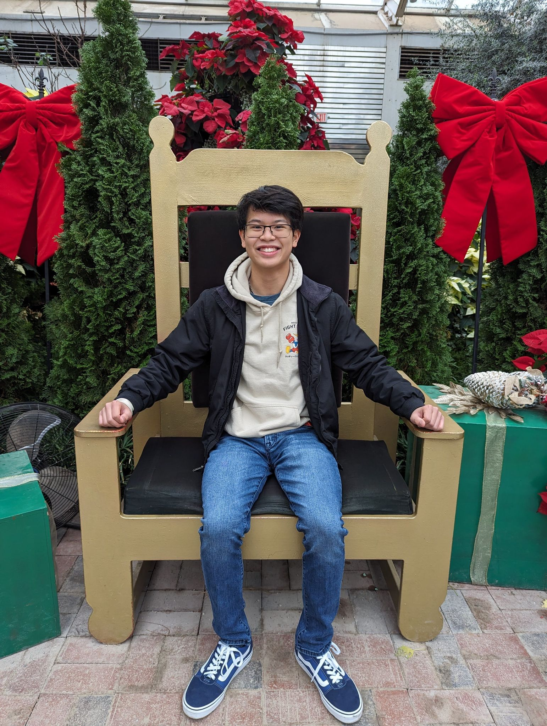

* My name is Timothy Chan and I am a computer science major with specialization in software engineering. I am a junior, but I plan on graduating this spring as I have my requirements completed. Most of my prior coursework has been very coding heavy and software oriented but I have had an interest in hardware in the past. I have enjoyed building computers but have never delved past the surface of the components. I also have family that has experience with the hardware side and I think it will interesting to see a little of what they work on often. I think the most interesting part of the hardware I am interested in implementing for this course is the light sensor and its active states. Specifically the power aware programming. I think it will be interesting to actually have a physical item use my code compared to my previous courses where my code mainly only existed on my computer.

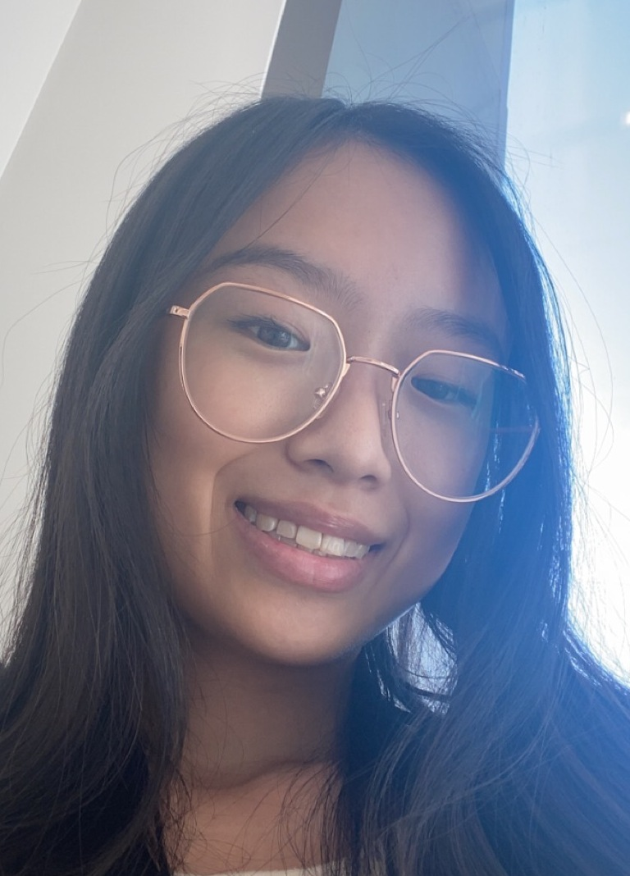

* I’m Selina Zheng and I am also a computer science major with a specialization in software engineering. This is my third year, but I am technically a senior. I hope to pursue my accelerated masters this fall. I am most interested in working with the hardware in this project. Previously, my only experience with hardware was building a very bare bones PC in my introduction to computer science course in high school. At IU, I have only worked with creating software, so I am excited for the opportunity to learn how to work with and program hardware. I am interested in learning how to connect the hardware to the software we will write, even though I am nervous about how to integrate the two.
* What dimension of the project is most concerning to the team?
  + With the objective in mind, the most concerning dimension of the project is the hardware components. As computer science students, our classes have been strictly focused on learning programming languages and writing software. Working with the hardware will present new challenges. In addition, the debugging of the hardware components is concerning as well because there will likely be concepts and ideas that are different from the software aspect. It will be interesting to see how debugging hardware works, as compared to debugging code. We have never used any type of test equipment like oscilloscopes, protocol analyzers, or multimeters, which will require a different level of care and attention to detail. We imagine that breaking code is quite different from breaking a hardware component. We are also concerned about working with C and Eclipse; from our previous experiences, this language and IDE have been challenging to work with. Hopefully it will not be as difficult because we have been exposed to it before and will be using these tools for a new purpose. However, this will be an opportunity to round out our knowledge since we will get to use physical technology. It will also allow us to use different debugging tools that we might see again in the future.